# 

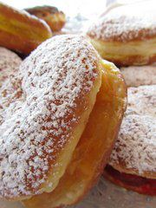 Paczki Day/Mardi Gras 2022

* Paczki’s - $ 2.65 ea. or $ 31.80 per dozen – Sliced, filled and dusted w/powdered sugar

Apple Apricot 2.Blueberry Cheese Cherry Custard*

Lemon Peach Pineapple Raspberry Strawberry

*Custard filled Paczki’s are not sliced and are offered with either powdered sugar or chocolate topping

* Mardi Gras King’s Cake – $ 19.75

## Choose from 3 Flavors - All Butter, Almond, or Raspberry. Rectangular ring coffee cake with Green, Purple, & Yellow Sugar. Mardi Gras Beads and the Traditional “Good Luck Baby” for decorations.

* Mardi Gras 7” Sprinkle Cake – $16.55

Yellow & Devil’s Food Cake with White Butter Cream filling and Icing.

* Pre – Packed Cupcakes (6) – $ 9.95
* Bon Bons – $ 1.95

Square Shaped white cake layers filled with strawberry preserve filling and topped with Colored Fondant Icing. Mardi Colors, sugar lay-on, and pixie dust make these individual cakes both festive and tasty.